Course: Web Application Development
Lab Instructor: Dr.Nguyen Van Sinh
Email: nvsinh@hcmiu.edu.vn

Lab 1: Setup Environment & Implement a Website
Date: March 11th, 2022
Content:
- Setup IDE: NetBeans (latest version, server: Tomcat/Glassfish)
- Setup database: MySQL (database server), Navicat Light(administration tool)
- Implement a website using HTML

Duration: 3 hours

Part 1: Setup NetBeans IDE (you can also use Eclipse if you want)

The source program copy from Instructor, you can go to this website: www.netbeans.org/ to have an overview of Netbeans or download the last version.

This is an example of Interface when finish installation: (note: you should download the latest version)

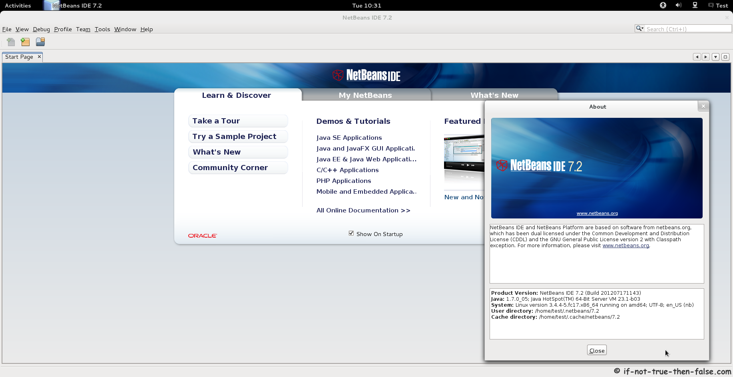

Create a website to test Netbeans environment: Select File > New Project > Java Web > Web Application: If Web Application project template does not exist, that means Web Applications plugin is not installed. You can install it by choosing Tool>Plugin>Available Plugin then choose Web Applications
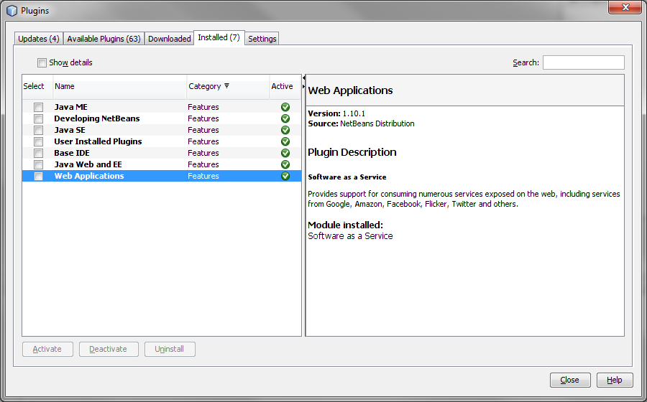
Screen of plugin installation

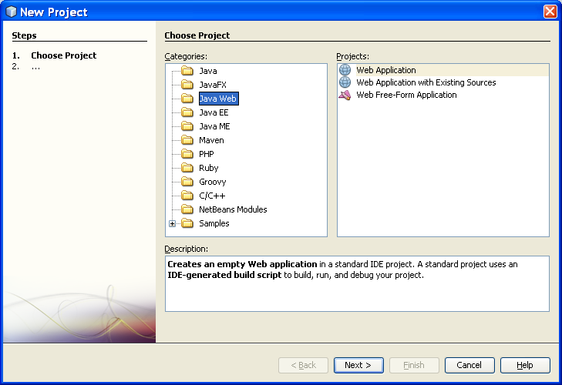

Click to “Next”, then fill in the Project Name; Name and Location, then go to Next button.
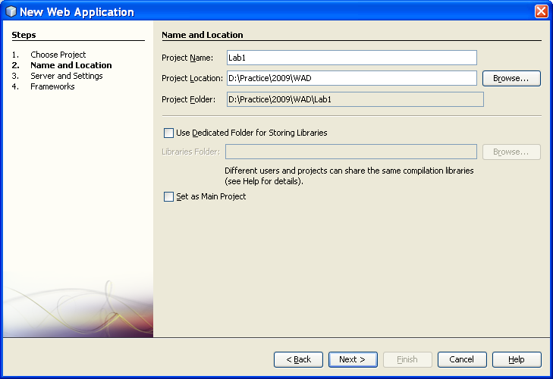
Choose a place where you can store
Choose the web server (there are two web server: Apache Tomcat & GlassFishV2)
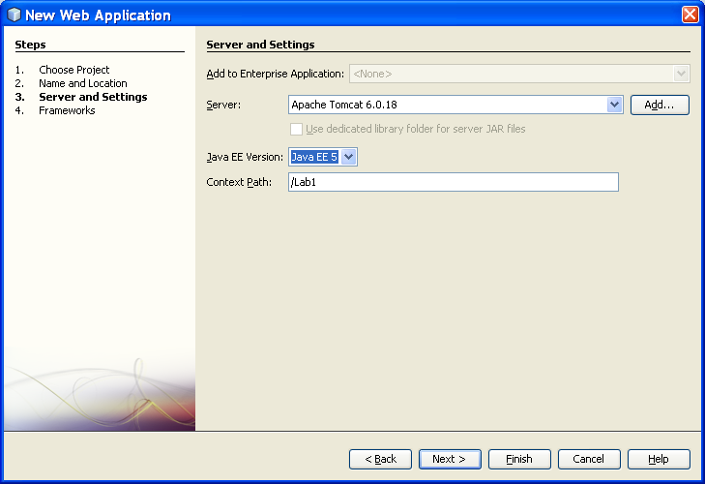

Now click on Finish button to complete an example of web application.
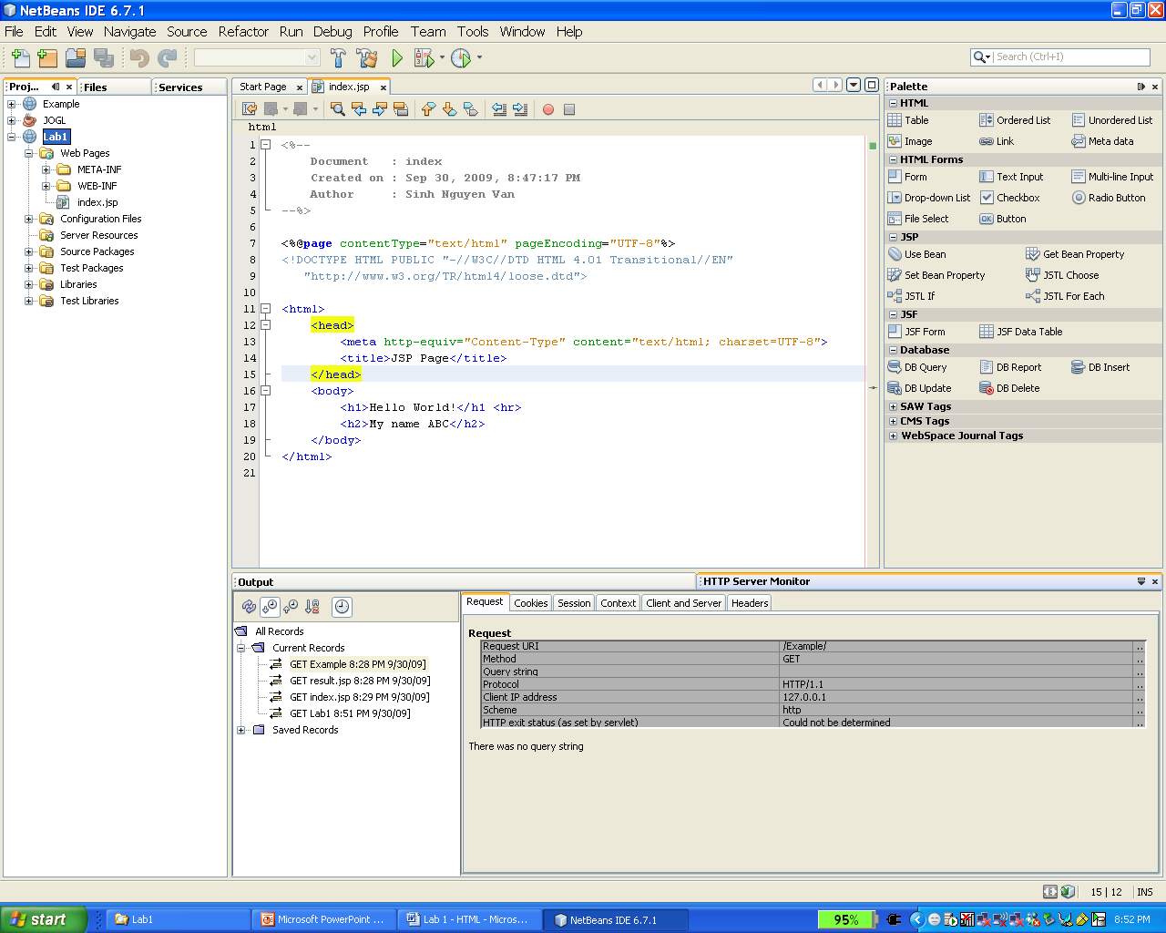
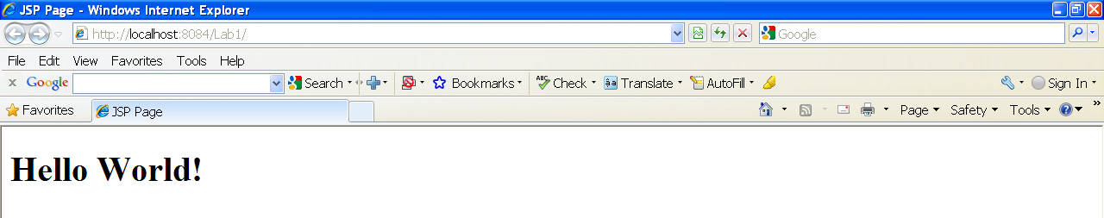
Part 2: Setup MySQL (Database System) and Navicat Light (Tool)

In this Lab, we will install MySQL version 6.0 (source program refer from Instructor). MySQL con be controlled by two administration interfaces:
- Console (built-in console)
- Graphic User Interface (Third-Party Tools)
Third-party tools are softwares provided by many vendors, such as MySQL GUI, Navicat,… You can install Navicat Lite for MySQL. In this section, you will learn console and Navicat
- MySQL console
Steps to launch console:
- Open window console by run “cmd” command on “Start” menu
- Locate directory contained file “mysql” (it is usually located in bin folder of installed folder). Do not forget your username and password of mysql when you was installing.
- Run mysql as figure bellow
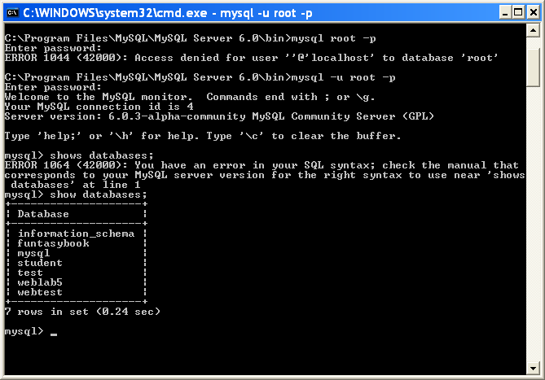
- After connected to database, you can test MySQL feature by typing something. The syntax and purposes of command can be found on internet.
- Navicat (Trial version)
- Install it on your computer
- Connect to database, using same information as console. But you can type them on graphic user interface now.
- Test Navicat features with your mouse.
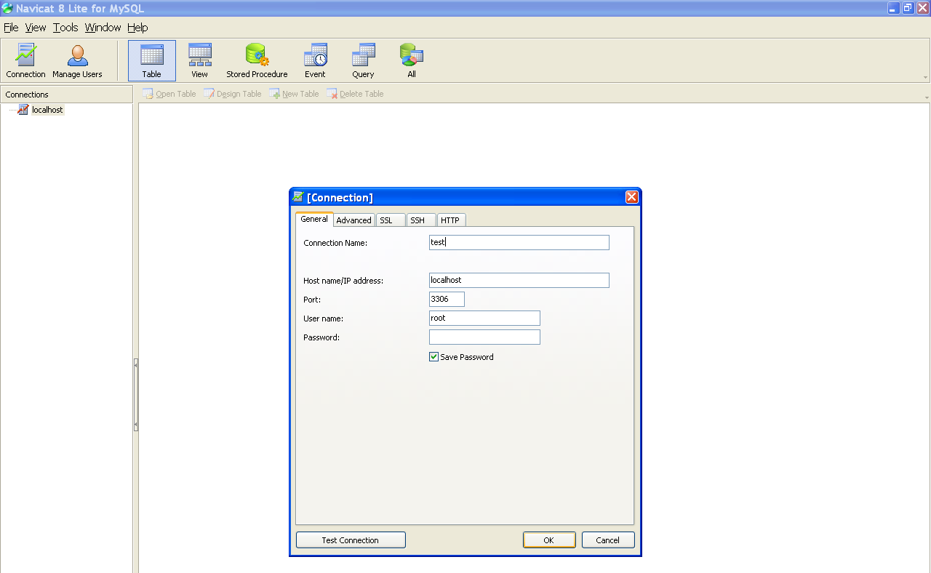

Extend: Install the tools for drawing some diagrams (Use case, Sequence, Databases, Architecture): Power designer, Visio, etc.

Part 3: Design your personal website using HTML + CSS

In this part, you will learn how to create a new web project by using NetBeans. You also learn how to modify the web application deployment descriptor. Then, you can start using the lab sample web application.

ASSIGNMENT 1: GO ON TO DEVELOP YOUR PERSONAL WEBSITE WITH THE FOLLOWING REQUIREMENTS:
- From 5 to 10 pages
- Using Frame, Images, Link, and all components of a form.
- Using CSS to decorate your pages
- Export your work, then upload to Blackboard before the deadline.
- Deadline: Please check on Blackboard
- I will check directly (one by one) on the next lab section.

